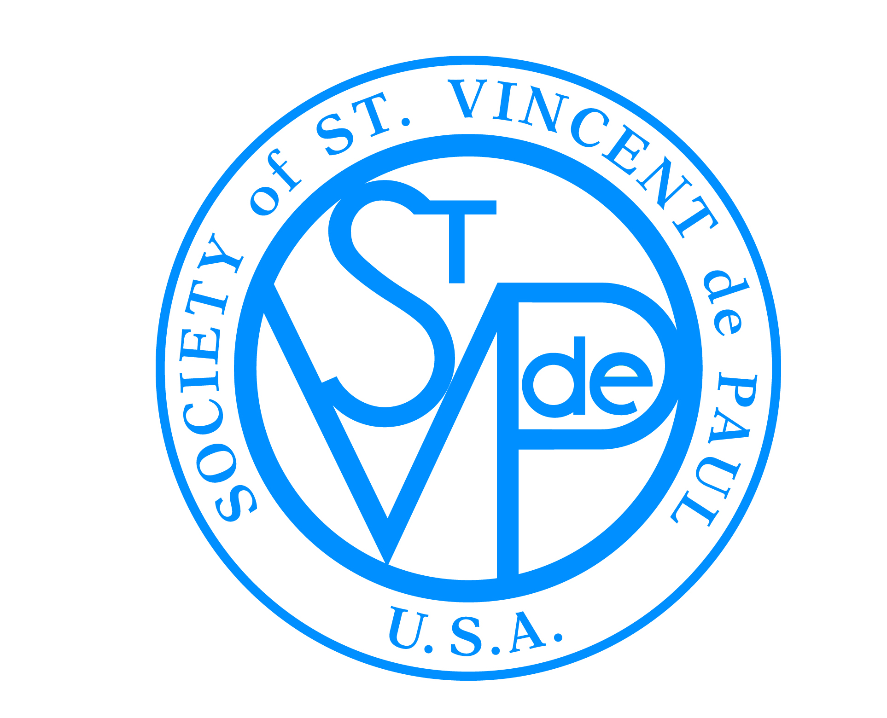

FRIENDS OF THE POOR® WALK/RUN
SOCIETY OF ST. VINCENT DE PAUL
®

Updated: 3/7/2016

Guide to Getting Started

Questions & Answers

What are the rules, or policies, of the FOP® Walk/Run?

By participating in the Friends of the Poor® Walk/Run, all SVdP Conferences and Councils are subject to compliance with all of the policies established for the Walk/Run. Please see the “Official Policies” document at www.fopwalk.org (Coordinators tab Toolbox Official Policies)

How can Conferences and Councils ensure that their information is correct in the national database so they can register their walk location and receive their funds?

Conferences and Councils participating in the Walk/Run must be sure that they are correctly registered (name, address, etc.) in the SVdPUSA national member database; incorrect names and addresses will inhibit a walker’s ability to select your Conference as a beneficiary of funds, as well as inhibit your receipt of online Walk/Run pledge funds. Because many local SVdP’s do not have physical locations of their own and use parish addresses or the personal addresses of their presidents to receive mail, Conferences and Councils should encourage the appropriate higher level Council to update their portions of the national membership database. For access, Council presidents should email Mike Schottenhaml of the National Council’s IT Department at mschottenhaml@svdpusa.org. In addition, every Conference and Council receiving funds must have an updated EIN information in the database, to ensure that they are legally able to accept donations being passed through the website.

Who will receive the money walkers raise?

When a walker/runner is registering online, he/she designates his/her support to a particular Conference or Council. 100% of the dollars raised by the walker/runner are paid to the Conference or Council as designated by the walker/runner. This event is also set up to enable walkers to participate in one location, but fundraise for another local Conference/Council, should they choose.

How are walks/runs coordinated between Conferences and Councils?

Walks/Runs can be organized and implemented individually by Conferences or Councils. Conferences have the ability to host a local event by themselves, or in conjunction with other Conferences. Additionally, some Councils choose to host an event, thus providing logistical support to ensure a potentially larger and more lucrative event. Regardless of where the walker/runner actually participates, pledges will be credited to the Conference or Council of their choice, which is designated by the walker/runner in the “beneficiary” section when registering.

Can we pick another date for our walk/run?

If the national date for the Friends of the Poor® Walk/Run is in conflict with another community event, you may pick another date that is within a 30 day window, before or after, from the official national walk/run date. Please advise Nathan Martin at nmartin@svdpusa.org if you need to host your walk/run on another date.

How do we get people to participate?

The easiest way to get a base of participants is to enlist the support of your Conference members. Ask each member to attend with at least five friends or family members. That will be your core group. Since many people enjoy competition, you might issue a challenge between multiple service clubs, schools or other organizations to see who can get the highest percentage of participation. You can send out a press release to local news media (there is a sample local press release on the website). Use your personal and work e-mail to invite friends, family, and co-workers. Send out a short invitation offering them to walk with you, and if not, support you with a financial contribution. Also, ask each of your e-mail contacts to bring friends or pass along the word about your event. Invite prominent community leaders to talk about the walk/run at community meetings and events. Also ask their participation, and mention them in the press release.

How are walkers/runners registered to participate in the walk?

Walkers/Runners can register using the online registration system at www.fopwalk.org (after the walk location has been registered), or directly with their respective Conference/Council using the paper registration forms found online.

Where do I get the Accident Waiver and Release of Liability Form?

All Friends of the Poor® Walk/Run participants and volunteers must sign the
“Accident Waiver and Release of Liability Form” that is provided on the website at Coordinators Toolbox Getting Started. Any walker who registers online does has already agreed to this Accident Waiver, and will not need to sign a hard copy on the day of the event.

What is the benefit of using the online registration/pledge system?

Use of the online system is strongly encouraged. The online registration system is a convenient and easy to use method to register as a walker/runner. A walker/runner can register, invite pledges, and view their progress using the online registration/pledge system.

Online walker/runner registration dramatically reduces the amount of work for the Conference or Council by eliminating data entry work, manual credit card processing, receipt generation, tracking and report generation. Also, the National Council covers all credit/debit card processing fees, so you get back 100% of donations made online.

What is the registration fee for a walker/runner?

There is no official registration fee required to register as a walker/runner on behalf of the National Council Office. We encourage participants to fundraise as a “pledge-a-thon” event, rather than collect a flat registration fee.

How does the website work?

The Friends of the Poor® Walk/Run home page, www.fopwalk.org, provides access to the “Coordinators” tab that has electronic forms that can be downloaded and printed locally. Other materials are also provided to support your local efforts. All monies collected through the online credit card system will be paid, upon final tally, by the National Council to the respective Conferences/Councils, as designated by each specific walker/runner.

How do the pledges work?

As the Walk/Run is expected to be operated on a fixed-length course (selected by the local Walk/Run Conference or Council organizers), the pledges are solicited in a fixed amount – not in a “$ per mile” concept. Pledges are collected at the time the pledge is made, both with the online system and the paper-based system. Online funds are given back directly to the local Conference or Council, and offline money can be collected the day of the event.

Can I raise money from local sponsors to help underwrite local costs?

Yes! You can also seek sponsorships for products used at your event. For tips and sample forms on how to solicit donations and recognize your local sponsors, see the website (Coordinators Toolbox).

How can we increase the chances of greater media attention?

The website (www.fopwalk.org) offers a full list of things to do to achieve the best success in penetrating and growing local media attraction to your event. If you have questions, please also contact Gary Stevens of the Communications Department at the National Council Office, by calling (314) 576-3993 x209, or by email at gstevens@svdpusa.org.

Do we need to do any record keeping?

Conferences and Councils are strongly encouraged to maintain complete and accurate contact information for all walkers/runners and donors. In addition, accurate receipts of offline monies received should be provided in a timely manner to the donors. A receipt template is provided on the website, for all walkers to provide their donors as they make their pledge.

At the end of the event, you will be asked to fill out a report form; please see the question below for more information on reporting.

Do I need to do a final report? How does it work?

Any Conference or Council who hosts a Walk/Run must make a report of all the Walk/Run revenue, total number of walkers/runners, and dollars raised, on the required form to Nathan Martin at nmartin@svdpusa.org, or faxed/mailed to the National Council Office to the Attention of Nathan Martin.

Please submit the required reporting forms by the requested dates to ensure timely delivery of online funds.

How do the online funds work?

The website will be open for online donations for 30 days beyond the official FOP® Walk/Run date. After this date, the checks for 100% of the donations will begin being processed, and then mailed out directly to the designated beneficiaries.

What are the details on the Walk/Run t-shirts?

The National Council partners with a vendor, which produces and distributes the Walk/Run t-shirts at a very reasonable price. Since 2012, these shirts are no longer free. You can still have your local corporate sponsors printed on the back if you wish, although the pricing will vary by size and quantity. Youth and adult sizes are available. Shirts prices and ordering can be done on the Walk website at www.fopwalk.org under the “Coordinators” tab.

Event Checklist
- Identify who will be your “Walk Coordinator” for this event.
- Register as a Walk/Run location on the walk website, by going to the “Coordinators” tab at the top, then selecting “Establish a Walk” sub-tab.
- Identify and contact individuals willing to assist in leadership capacities, and ask them to assist as the walk committee (not every walk location has a committee, but it does ease the load of the walk coordinator).
- Make the decision if you want to do the walk on a small scale, or make it a large event with entertainment, walking city streets/park, etc.
- Select a location to have this event. If first year, and a smaller event, church grounds or a local high school track will require permission, but is typically easy to obtain, and rarely require any permits. If hosting event on a larger scale that requires streets to be shut down, police escort, etc., then you will need to obtain necessary permits.
- Check for liability insurance, and make sure you meet necessary minimum requirements.
- Recruit walk day volunteers
- Identify event needs (such as table/booths, food, water, walk routes, signage, etc.)
- Enlist local business involvement for in-kind donations (water, snacks, etc.)
- Recruit corporate sponsors for the event (National Council Office has sample letters, levels, and forms for this – great way to bring in additional funds!).
- Distribute promotional materials and registration forms to promote walker participation (promote at city events, after church, parish events, nearby churches, schools, youth groups, outside clubs, and community organizations).
- Order t-shirts (typically six weeks before walk date)
- Send out a press release for media coverage of your event.
- Continue promoting walker registrations (sample flyers, brochures, and pamphlets are on the website to help)
- Encourage current walkers to create a team, bring friends, and continue to ask for pledges for the event.
- Assemble volunteers and confirm their duties for walk day event
- Set-up day of event
- Clean-up post event (volunteers lined up to assist with this, great way to get youth and young adults involved! Ask the Boy Scouts, Girl Scouts, high school clubs, etc., to help with this.
- Post-event evaluation for next year
- Turn in post-event report form to National Council Office (Nathan Martin) with your results.

